Q1
After graduation, three IT students decided to start a software company called SmartComputing. You had just been hired as a software engineer by the founders.
On your first day in the new job, you asked the Chief Technology Officer (CTO) about SmartComputing’s software engineering process. She replied:
We follow the Unified Process to make sure we develop the right product in the right way. The process consists of five distinct workflows. We complete all the tasks and confirm all the documentation in each workflow before we move on to the next workflow.
The first workflow is the Requirements Workflow, where we brainstorm ideas about features that our customers will love to have.
The next workflow is the Analysis Workflow. This involves analysing the problem domain more deeply and describing the requirements in the kind of exacting detail that developers need. Typically, in this workflow, we will produce conceptual class diagrams, detailed use case scenarios, interaction diagrams and statecharts.
Once the Analysis Workflow is completed, we begin the Design Workflow, where we refine the conceptual class diagram into something more concrete, producing a detailed class diagram.
The next workflow of the process is the Implementation Workflow. In this workflow, we write the code to implement the detailed class diagram produced in the previous workflow.
Finally, we will have the Test Workflow, where we test our program to ensure that the system works correctly.
Required Task
Based on what you have learned in FIT5136, analyse and critique the company’s software engineering the process described above by the CTO.

Q2
You then asked the CTO about the latest project the company is undertaking. She mentioned that the project is to develop an online learning platform called Poodle 2 system for the university.
The first task you, as the software engineer, are assigned for Poodle 2 is the analysis of the functionality of adding students to the system:
An administrator is able to add a student enrolled in a unit. An administrator can also list the students added in the last 24 hours and also delete a student if it was added by mistake.
Required Task
Draw a UML use case diagram for this functionality.
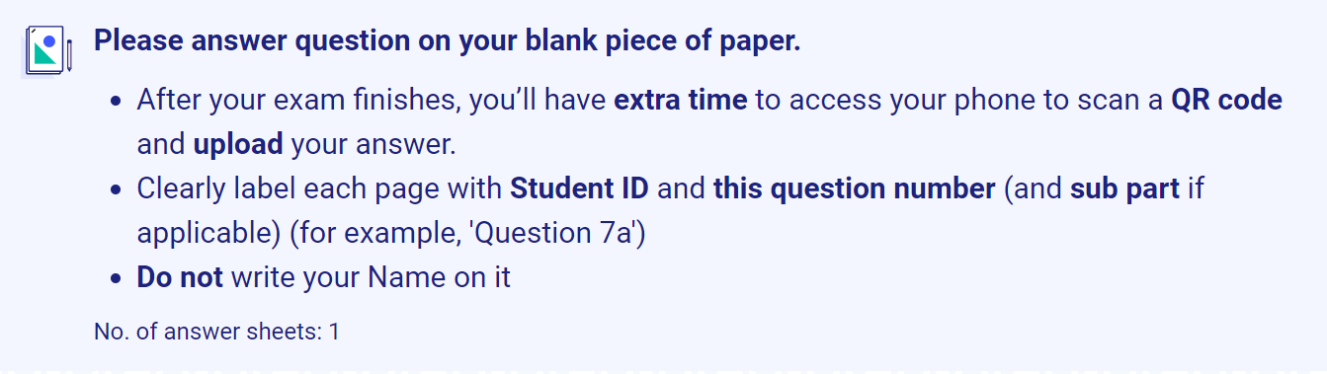

Q3
Below is a detailed description of the normal scenario for the “Add Student” use case, with no exception conditions.
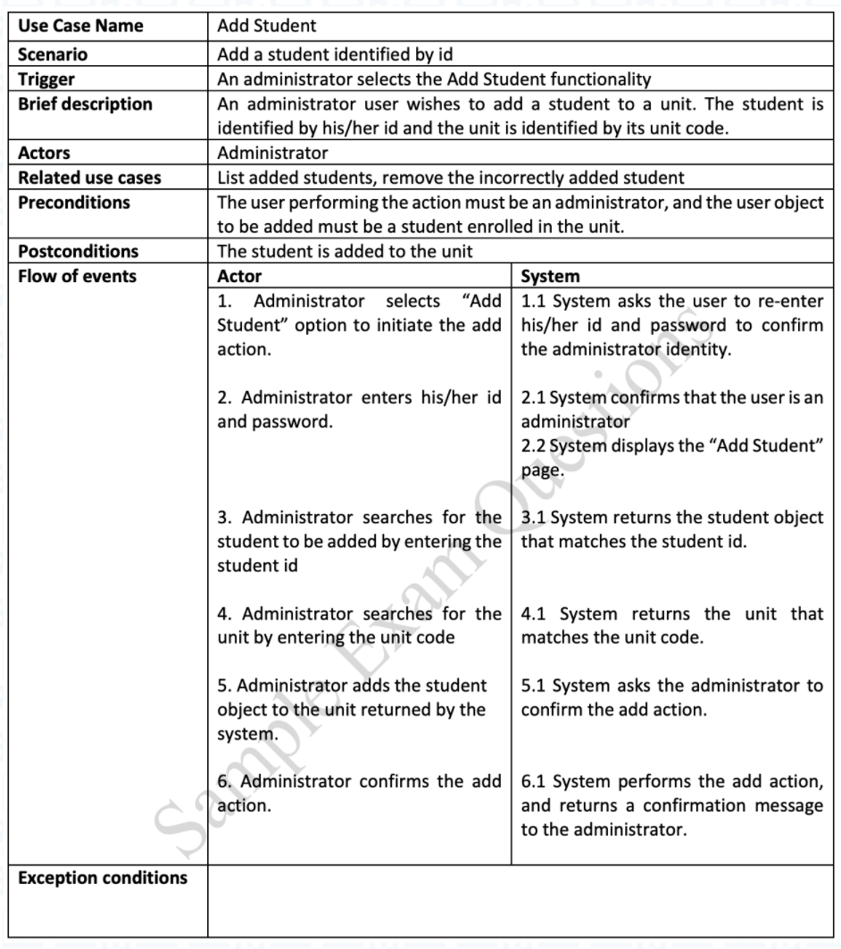
Required Task
Write three exception conditions, including reasonable actions to be taken.

1) Exception Condition

2) Exception Condition

3) Exception Condition

Q4
The CTO provides more description of the Poodle 2 project below:
The university that we graduated from has a very bad on-line learning platform called Poodle. We were asked to improve and extend the current system. I think we were successful in getting the project because three of us were former students and we had used their system before. Based on my experience, I can confirm that the system is really bad and definitely needs improvements. We call this project Poodle 2.
Every user of Poodle 2 is identified by an id and a name. To use the system, every user will need a password to log in. In Poodle 2, administrators can create units. Each unit is identified by a unit code and a unit name. Teaching staff can create contents in units they teach and each teaching staff can teach up to four units. Students have access to the contents as long as they are enrolled in the unit. Every student can enrol in up to four units. An administrator can add a student to the unit if the student is officially enrolled in the unit. An administrator can also delete a student from the unit if the student is no longer enrolled.
Students are allowed to comment on units and contents in Poodle 2. Comments on a unit and comments on its contents can only be created and viewed by students currently enrolled in the unit and staff teaching the unit. Users given authorisation can post replies to a comment. A lecturer of a unit or an administrator can remove a comment if the comment is deemed inappropriate, irrelevant or not useful in general.
Required Task
Based on the CTO’s description of the Poodle 2 project above and in Question 2 and the use case scenario in Question 3, you are tasked to produce an initial class diagram for the project.
Develop an initial UML class diagram for the system, with the relevant classes and attributes resulting from your dictionary of abstractions. Concentrate on modelling the problem domain rather than any boundary or control classes. Make sure you:
- include appropriate attributes for the classes
- describe the relationship between classes using generalization, association, and aggregation
- indicate the multiplicity (cardinality) of the relationships properly.
- DO NOT include responsibilities or operations. You do not have all the information at this point to do so.

Q5
Having completed a few features with tight schedules, your talent had finally been recognised by the founders of SmartComputing with good recommendations from your team leader.
One week before the project deadline, the Chief Technical Officer (CTO) called your team leader into her office and showed him a piece of functionality implemented in the latest version of a competitor’s software, Noodle. The CTO said, “This is a feature we must have! Please ask the team to implement it by the end of the week so that we can demo the feature to the university.”
You were asked by your team leader to start designing it. After thinking for a couple of hours, you came to the conclusion that Poodle 2 was so different from Noodle that this feature simply didn’t make sense for Poodle 2. Moreover, it was not only difficult to implement, but it would also make the system less reliable. You went back to the team leader to discuss these issues with him. The team leader then had a meeting with the CTO and explained your concerns to her.
After hearing the team leader’s explanation, the CTO was still adamant about including the feature in Poodle 2. To convince the team leader that it was easy to implement, she showed him the source code of Noodle, which is free and open-source, and asked him to “just copy their code then you’re done!” The team leader went ahead, followed her suggestions and completed the implementation on time for the demo.
Required Task
- What are the ethical and professional issues that arise with the behaviour of the CTO and the team leader in this situation?
- How would you evaluate their behaviours
- In your answer, you must refer to the applicable parts of the Software Engineering code of ethics.

Q6
The SmartSolutions software company had a contract with a transportation company, TransCo, to add a new component to their existing scheduling tool. The new component was to be a smart reasoning component for recommending routes to drivers. After the first version was delivered, TransCo decided that the new component would have to contain more features to allow maximum flexibility for users (“event 1”).
After incorporating these and the second version was delivered, SmartSolutions found out that the company producing the constraint solver library that it was using had gone broke, so it needed to change the design to use a different library(“event 2”).
Then SmartSolutions realized its own analysts had misunderstood one of TransCo’s requirements, so they had to re-do some of the analysis (“event 3”).
Required Task
Below is an “empty” depiction of the Unified Process. Extend the figure to represent (roughly) the relative effort given to the different workflows during this project. Indicate on the x (time) axis roughly when “event 1”, “event 2” and “event 3” occurred.
